MIC Summer School Budapest
26-30 Augustus 2024

BUDAPEST

Venues: Ludovika University of Public Service, Research Centre for Natural Sciences
Address: HU-1083 Budapest, Ludovika square 2.; 1117 Budapest, Magyar tudósok körútja 2.
Web: www.en.uni-nke.hu ; https://www.ttk.hun-ren.hu/en

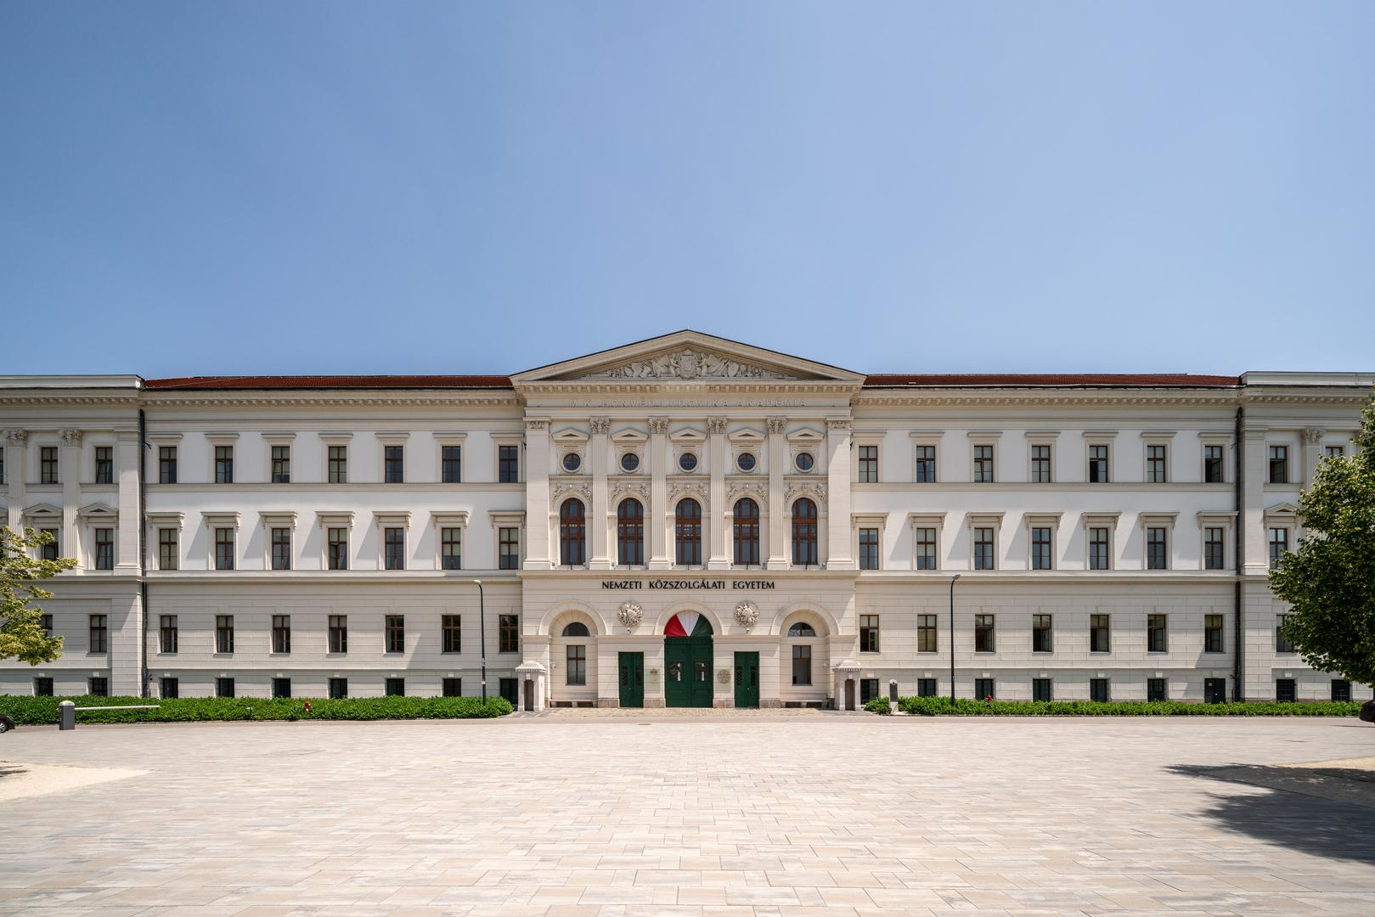

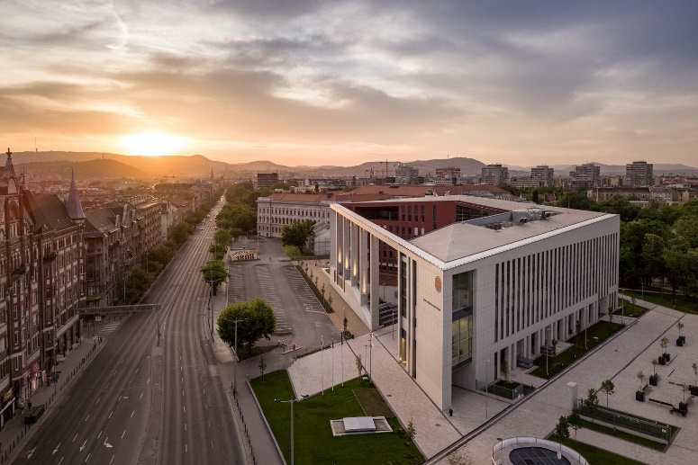
About LUPS__________________
Established in 2012, it is one of the youngest universities in Central and Eastern Europe; however, its former independent colleges look back to its faculties much earlier. The Zrínyi Miklós National Defence University was officially established in 1996. Still, it had several predecessors dating back to the early nineteenth century. The most notable is the Royal Hungarian Ludovika Academy, which was established on 8 November 1808. The academy was not only the first Hungarian military higher educational institution but was acknowledged to be on an equal level as the Theresian Military Academy in Austria in 1897, making the Ludovika Academy an internationally renowned centre for military sciences and officer training. After the renovation, the campus centre was equipped with up-to-date technology and infrastructure while keeping its original trademarks in a neo-classicist style. The Orczy Park and its surroundings provide an area of 73,700 square metres (18.2 acres) for the new campus altogether.
The university's primary goal is to educate future public administration officials and military and law enforcement officers (through BA and MA programmes) and to develop current public service members (through different training programmes). Moreover, UPS also functions as a think tank for public service (through PhD programmes, joint conferences and individual research activities of lecturers). The University mentors and orients new generations of creative, educated, community-building, ambitious young people who want to learn, respect national values, are solidary and cooperative, and are also responsible for the future to build Hungary and Europe with their best knowledge.
While modern Hungarian higher education has always included programmes focusing on the education and training of people primarily preparing for public service, Ludovika-UPS is the first university in the country exclusively dealing with the formation of future public servants. The university provides a motivating environment in which its employees serve the university's goals with the continuous development of their knowledge, a predictable vision and ambitions.

Ludovika map____________________________________________________
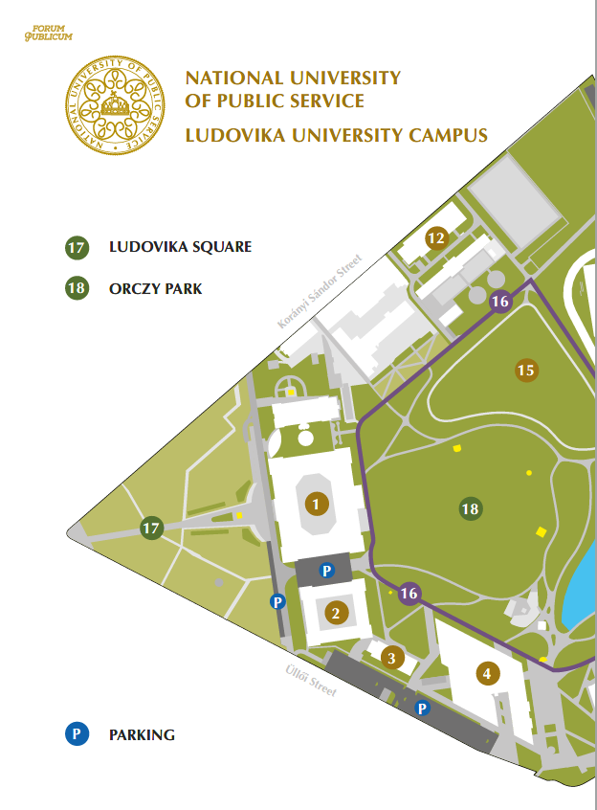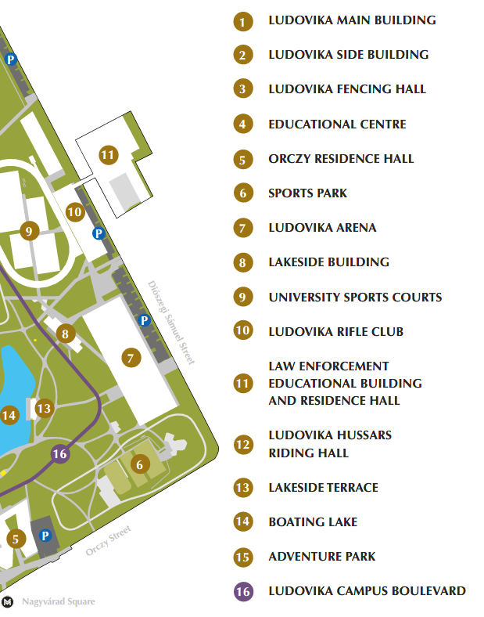
Contact persons (for the event)_______________________________________

Judit Knisz, PhD
Ludovika University of Public Service (LUPS)
Hungary
Email: Knisz.Judit@uni-nke.hu

Melinda Markotán
Ludovika University of Public Service (LUPS)
Hungary
Email: Markotán.Melinda@uni-nke.hu

Practical information ____
Insurance
Before you arrive in Hungary, you are supposed to arrange your insurance for your whole stay in Hungary. CEEPUS does not cover the cost of insurance in Hungary.
Weather
Budapest weather in May is rather mild/hot: Daily high temperatures increase by 4°C, from 19°C to 23°C, rarely falling below 13°C or exceeding 29°C. Daily low temperatures increase by 5°C, from 9°C to 13°C, rarely falling below 4°C or exceeding 17°C.
https://weatherspark.com/m/84771/5/Average-Weather-in-May-in-Budapest-Hungary
Time zone
Central European Time (CET) UTC+1
Currency
"Forint" is the currency of Hungary. 1.00 Euro ~ 390 Hungarian Forint. In Hungary, credit and debit cards, especially Visa, MasterCard and Maestro, are widely accepted. You can use them at many restaurants, shops, hotels, car rental firms, travel agencies, petrol stations, or even in taxis.
Electrical Socket
For Hungary, there are two associated plug types, types C and F. Plug type C is the plug, which has two round pins, and plug type F is the plug, which has two round pins with two earth clips on the side. Hungary operates on a 230V supply voltage and 50Hz.
(Should you leave your adapter at home, we can help. )
Emergency Numbers
General – 112
Police – 107
Ambulance – 104
Fire Service - 105
Public Transport and Taxi ____
You can travel using public transport or a taxi.

All legal and registered taxicabs must be yellow and operated by a meter. According to the law, any starting and call-out charges must be displayed on the backside windows. At the airport, "Főtaxi" can be ordered at the kiosk after exiting the airport building. Licensed taxis use the same tariffs.

Base fare: HUF 1100 / Price per minute: HUF 110;
Price per Kilometer: HUF 440
FŐTAXI: +36 1 222 22 22
CITYTAXI: +36 1 211 11 11
TAXIFY (NOW BOLT): +36 1 444 51 54
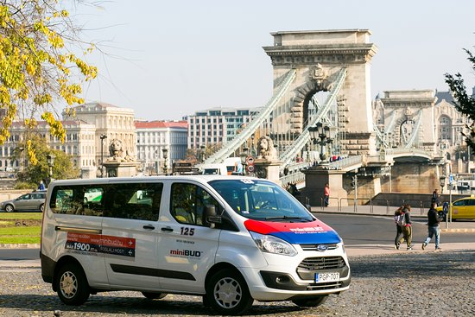
Airport Shuttle____________________________________________________

MiniBUD is the official airport shuttle service provider for Budapest airport. Convenient, fast and environmentally friendly door-to-door transfer.
SERVICES
- miniBUD airport shuttle service
- BUDAPEST CARD - Sale of the official city card
- HOP ON HOP OFF – The best Budapest sightseeing tours
- FAST TRACK - Fast track lane service, passenger security screening without queuing
- Other services
Call center: +36 1 550 0000
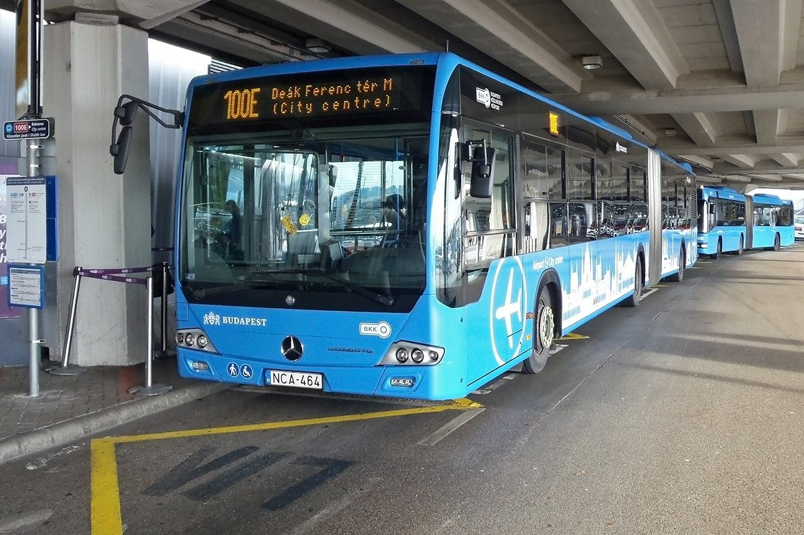
The regular № 200E bus line covers the route Budapest Liszt Ferenc Airport–Kőbánya Kispest Metro 3 terminal, and № 100E bus line covers Budapest Liszt Ferenc Airport–Deák Ferenc tér (city center). № 100E bus is a direct service, and this is only available with an

Airport shuttle bus single ticket. (https://bkk.hu/en/travel-information/public-transport/airport-shuttle/)
There is no direct train or subway from the airport to the city.
The ticket should be validated immediately after boarding the vehicle if using public transport. When travelling by subway, you should validate the ticket at the entrance gate before entering the platform. Transport of luggage is free.

Tickets types and ticket prices (public transport)_________________________
- Single tickets and travel cards for one or more days
Tickets and travel cards (https://bkk.hu/en/tickets-and-passes/prices/) can be bought at ticket vending machines (TVM) at the airport and several points in the city (https://bkk.hu/pontkereso/) or at your mobile phone after downloading the Mobile ticket app (https://bkk.hu/mobileticket/).
A single ticket costs 450 Forints or 600 Forints bought on the spot (service is not available on every bus!).
The single ticket should be validated by the barriers at the entrance to the metro stations or after boarding buses, trams or trolleys. Travel cards need not be validated; they are valid for 24 or 72 after the chosen date and hour for an unlimited number of travels.
- One-day (24h) card for all Budapest public transportation lines
The one-day card is valid for all metro lines, trams, trolleybuses, and buses of Budapest public transport.
The card allows an unlimited number of trips within the calendar day printed on it.
Cost – 2.500 HUF
- Three days card (72h) for all Budapest public transportation lines
The 3-day card is valid for all the lines of the metro, trams, trolley buses and buses of Budapest public transport.
The card allows unlimited number of trips within 3 calendar days.
Cost – 5.500 HUF
- Block of 10 tickets for 10 single trips
You can buy them in the same manner explained above.
Cost – 4.000 HUF
- Budapest Card
You receive a one- to five-day public transport pass valid for all public transport in Budapest, depending on your choice. Discounts at around 40 sites throughout Budapest
More information about the card and the sites:
https://www.budapestinfo.hu/budapest-card
Cost – 9.900 - 29.500 HUF
- In case of travelling without a transport document or with an invalid one, the passenger must pay a penalty fare on the spot of 8.000 HUF or within 30 days 16.000 HUF.

Police Stations____________________________________________________

IX. District
Address: 7-9 Haller str, Budapest 1096
Phone: +36 1 455 4800

VIII. District
Address: 36 Víg str. Budapest 1084
Phone: +36 1 477 3700
Free time activities and sightseeing in Budapest__________________________
Budapest is Hungary's capital, most populous city, and the ninth-largest city in the European Union. The history of Budapest began when an early Celtic settlement transformed into the Roman town of Aquincum, the capital of Lower Pannonia. The Hungarians arrived in the territory in the late 9th century. In 1241, at the time of King Bela IV, who was considered the second founder of Hungary, the Tatars devastated the Pannonian area. Re-established Buda became one of the centres of Renaissance humanist culture by the 15th century. Budapest, the capital of Hungary, was created in 1873 by merging three cities: Buda, Óbuda and Pest.
Opened in 1896, the city's subway system, the Budapest Metro, serves 1.27 million, while the Budapest Tram Network serves 1.08 million passengers daily. The central area of Budapest along the Danube River is classified as a UNESCO World Heritage Site. It has several notable monuments of classical architecture, including the Hungarian Parliament and the Buda Castle. The city also has around 80 geothermal springs, the largest thermal water cave system, the second-largest synagogue, and the third-largest Parliament building in the world.
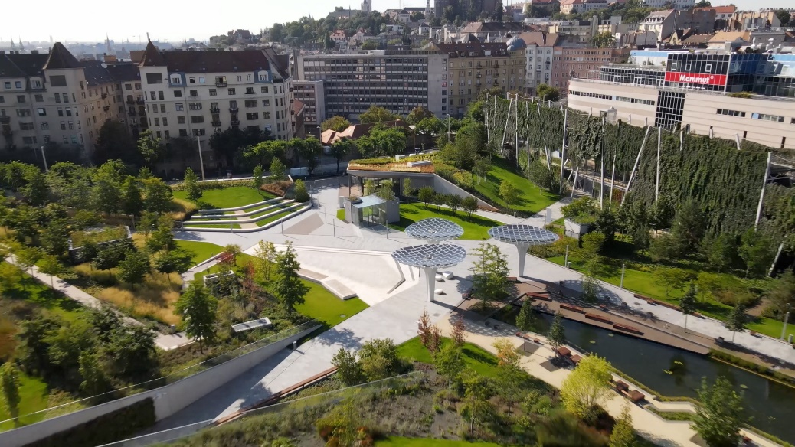
Park Millenáris
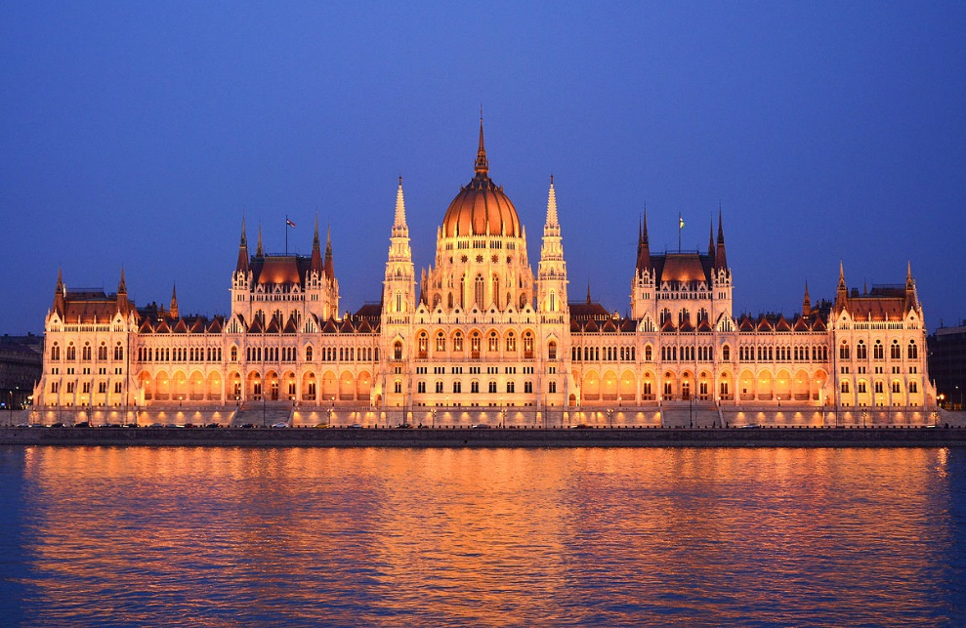
Parliament Tour

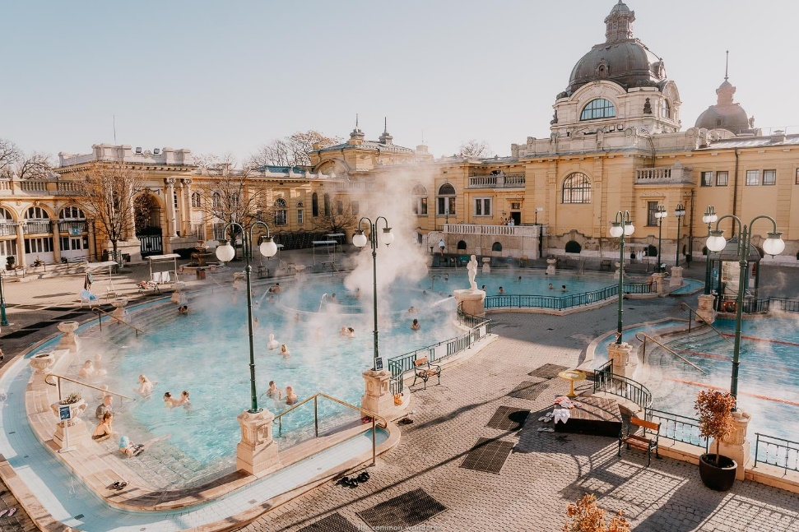
Szechenyi Bath
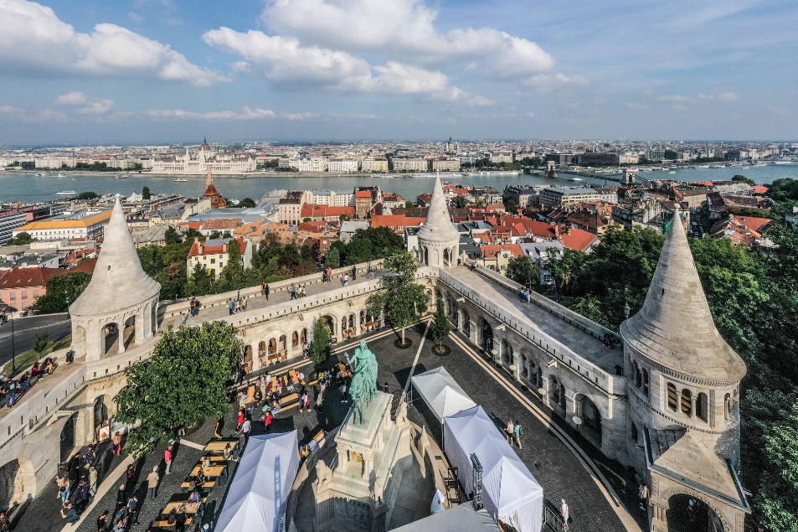
Fisherman’s Bastion

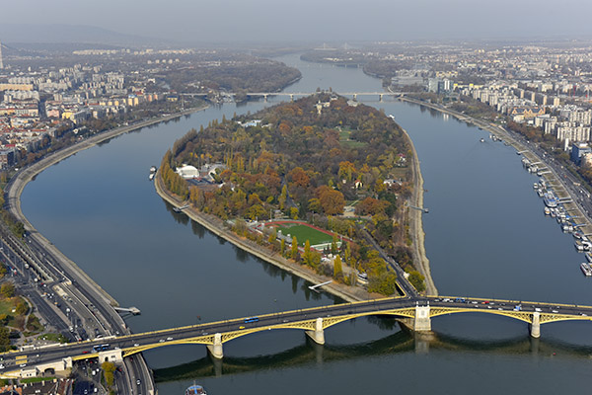
Margaret Island
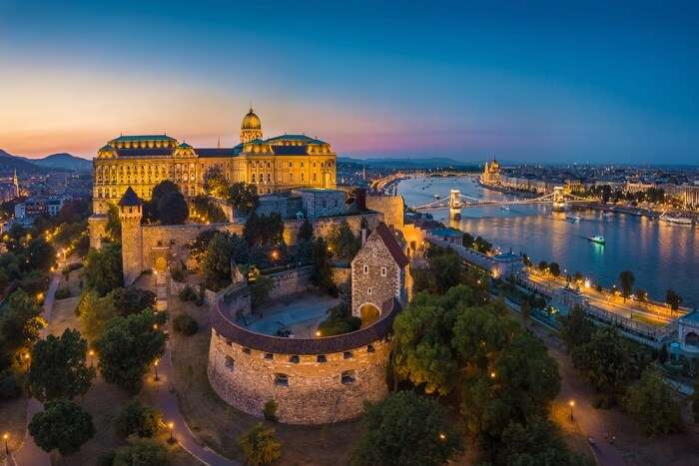
Buda Castle

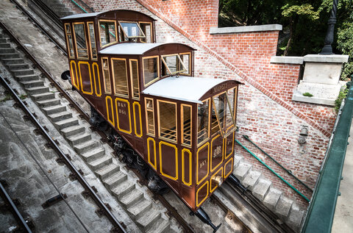
The Funicular

Enjoy your stay in Budapest!

